Physics final project:

Live Link: <https://perchance.org/physics-generator>

First Save: <file:///Users/lium/Project/Physics-Generator/physics-generator.html>

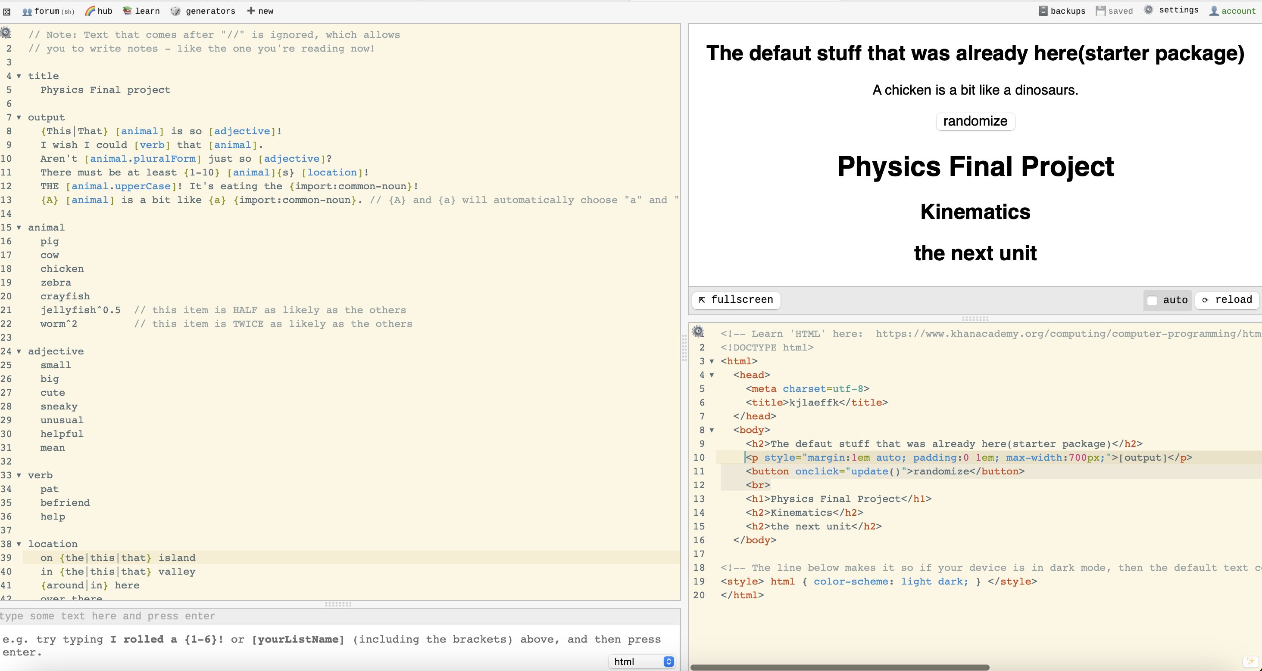

Second save: